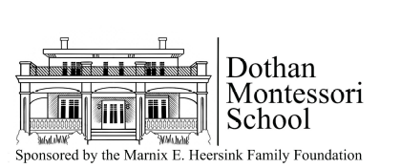
474 S. Oates St.
Dothan, AL 36301
334-209-8587
director@dothanmontessorischool.org
www.dothanmontessorischool.org

To Whom it May Concern:

Dothan Montessori School is seeking corporate sponsorships for the 13th annual Montessori Madness 5K and Fun Run on Saturday, November 7, 2026.

Providing exceptional educational choices for children in Dothan is key to strengthening our community. As the only non-profit Montessori preschool in Dothan, Dothan Montessori School provides one such choice. We hope that your business will support DMS by sponsoring the run at one of the sponsorship levels listed below.

- Platinum $1,000 donation – Sponsor “shout out” in race recap e-mailed to all participants and supporters; logo on race t-shirts; logo on promotional posters; logo on race website with link to your website; special recognition at the awards ceremony; your company is welcomed to set up a sign or banner at the finish line.

- Gold $500 donation – Sponsor “shout out” in race recap e-mailed to all participants and supporters; logo on race t-shirts; logo on race website with link to your website; special recognition at the awards ceremony.

- Silver $250 donation – Sponsor “shout out” in race recap e-mailed to all participants and supporters; logo on race t-shirts; logo on race website with link to your website.

With the support of generous sponsors like you, Dothan Montessori School will continue to bring this time-tested method of education to children in Dothan from ages 18 months – 6 years old. Thank you for your consideration.

DeeDee Neal Wendy Yarbrough
Director, DMS Assistant Director, DMS
334-671-7170 director@dothanmontessorischool.org
4

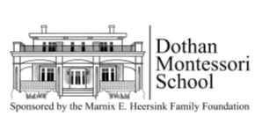
474 S. Oates St.
Dothan, AL 36301
334-671-7170
director@dothanmontessorischool.org
www.dothanmontessorischool.org

Thank you for your donation to Dothan Montessori School’s “Montessori Madness 5K and Fun Run”! This year’s race starts at 8 a.m. at Westgate Park, registration is at Kiwanis Pavillion on Saturday November 7, 2026.

Please fill out and return the form below by October 22. Corporate donations are welcomed and accepted after this date, but there is a possibility your corporate logo may not appear on the race t-shirt.

Please e-mail company logo in .jpg file to DeeDee Neal, director@dothanmontessorischool.org by Monday, October 20 for it to be included on race t-shirts.

SPONSORSHIP CONTACT INFORMATION
Company name_______________________________________________________________
Contact name/title _____________________________________________________________
Address_____________________________________________________________________
Phone number________________________________________________________________
E-mail_______________________________________________________________________

EVENT DAY INFORMATION
Do you plan on dropping off company promotional material for race day bags? Y____ N ____

Will you provide and set-up signage at the finish line (platinum only)? Y____ N ____

DONATION INFORMATION

Platinum $1,0000 _____ Gold $500 _____ Silver $250 ______

In-Kind (please describe) ________________________________________________________

Checks are payable to Dothan Montessori School, memo “5K Sponsorship,” and may be mailed to Dothan Montessori School, 474 S. Oates St., Dothan, AL 36301.

